Competition Title:
Home Team:

versus
Away Team:
Venue:
Match date:
Player Name |  |  | Pro Club Academy | D.O.B
1
2
3
4
5
6
7
8
9
10
11

Substitutes

12
13
14
15
16
Signature
Signed
Manager of

- It is incumbent on the participating team to ensure that they are compliant with the competition rules. Please go to https://schoolsfootball.org/national-competitions/competition-rules-2/ to read the full competition rules.
English Schools’ Football Association
INTER-SCHOOL OFFICIAL TEAM SHEET

- In individual school/college competitions, a maximum of three players who attend an FA Licensed Academy can participate in a match. Participation of the three players relates to their inclusion in the named squad. This rule does not apply to the Elite Schools’ Cup competitions. **Note: this rule does not apply to girls’ that are registered with Emerging Talent Academies (ETCs) or Professional Game Academies (PGAs)’’

- To be eligible to enter the Small Schools’ Trophy, the affiliated school must have fewer than 65 boys on roll in the specific year group. To be eligible for the U13 Girls’ Small Schools’ Cup, the affiliated school must have fewer than 130 girls on roll in Years 7 and 8 (in total). To be eligible for the U15 Girls’ Small Schools’ Cup, the affiliated school must have fewer than 130 girls on roll in Years 9 and 10 (in total).

- 'B' Team Cup: The cup shall be offered for annual competition to B teams of Schools in affiliated membership with the ESFA, and which have entered an ‘A’ team entered and fulfilled a fixture in the in the ESFA Under 13 Schools’ Cup (includes Elite Schools’ and Small Schools’ Cups). To be eligible for the U13 Girls’ B Team Cup, the school must have entered an ‘A’ team and fulfilled a fixture in each of the ESFA Under 12 and Under 13 Schools’ Cups for girls. To be eligible for the U15 Girls’ B Team Cup, the school must have entered an ‘A’ team and fulfilled a fixture in each of the ESFA Under 14 and Under 15 Schools’ Cups for girls. Players registered with an FA licensed academy are not eligible to take part in the ‘B’ Team Cup. Girls’ ETC (Emerging Talent Academy) and PGA (Professional Game Academy) players are not permitted in this category of competition (this is the structure replacing RTCs in The FA’s Girls’ Talent Pathway from 23-24 onwards).

- Boys’ competitions are for single year groups only. Girls’ competitions are for 2-year age bands only. Under 18 tournaments are for Years 11-13 only.

- Important Rule Change

There has been an important rule change regarding this season’s ESFA Boys’ Inter-School Cup competitions which will be applied as follows:
Rationale: the proliferation of “academy” type football programmes is manifesting itself in ESFA competitions and is creating unfair advantage for such schools who are not playing against comparable opposition. In order to provide a suitable route which accounts for these pupils without undermining the integrity of ESFA national competitions, it is proposed to accommodate such schools as described below:

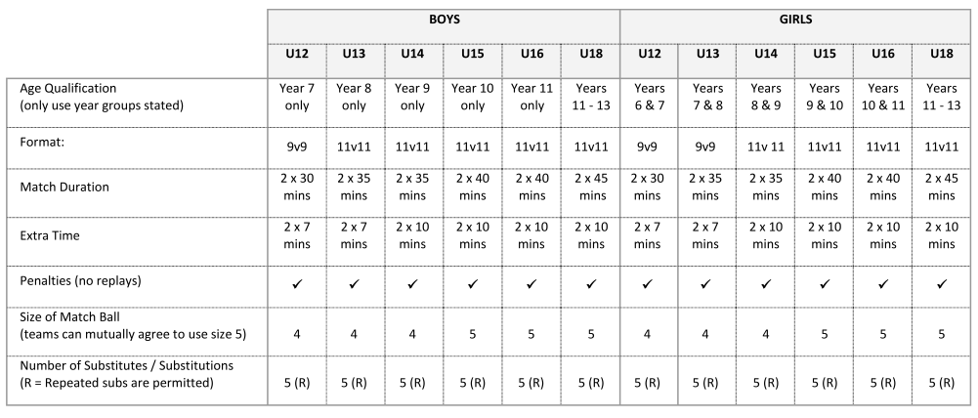
“Save for ESFA Elite Schools’ Cups and ESFA Girls’ Cups, establishments operating a ‘football academy’ during school curriculum time, shall not be eligible to participate in ESFA Schools’ Cups (ESFA Schools’ Cups, ESFA Small Schools’ Cups or ESFA B Team Schools’ Cups). Such schools shall be permitted to enter up to two teams in each age group of the Elite Schools’ Cup. ‘Football Academy’ status shall be applied at the discretion of the ESFA Council.

