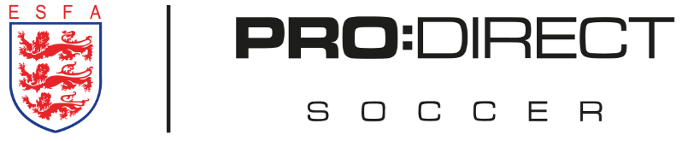
England U18 Schoolboys’ regional trial squad- South

Players Name | Players County
Kaiden Hummerston | Sussex
Daniel White | Norfolk
Harvey Gilham | Norfolk
Oliver Hart | Suffolk
Ollie Fraser | Suffolk
Jonny O'sullivan | Buckinghamshire
James Taylor | Bedfordshire
Tom Green | Kent
Victor Daniels | Kent
Jasper Sheik | Hampshire
Dominic Cupid | Hampshire
Jacob Towns | Gloucestershire
Joshua Radford | Gloucestershire
Laiith Fairnie | Gloucestershire
Luke Salter | Gloucestershire
Sam White | Wiltshire
Jowan Partridge | Wiltshire
George Newton | Cornwall

