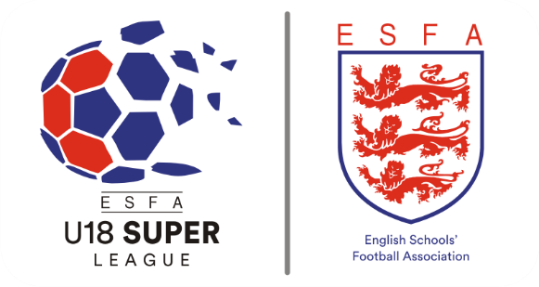

**ESFA Under 18 Super League  
Season 2022/2023**

**ESFA U18 SUPER LEAGUE - MEN’S COMPETITION**

Welcome to the English Schools’ FA Under 18 Super League!

This exciting format of competition is designed for those schools, colleges and private providers which offer a football academy or development programme at the sixth form level. If your establishment offers such a programme which allows your students to benefit from regular football training, strength & conditioning and possibly analysis sessions, then this is the competition for you! All matches are played outdoor using age appropriate pitch and goal sizes in accord with FA rules. Please note, we will be using League Republic as the platform to host fixtures, results and league tables.

**FORMAT AND OVERVIEW**

**Group Phase:** This competition is based on a League format. Teams have been drawn into one of 19 leagues. Each league will comprise of 4 or 5 teams with each team playing each other once in the group phase. In the group phase a win will gain 3 points, a draw will gain 1 point and a defeat will gain 0 points. The highest ranked team in each league will be determined using the following:

1. Points
2. Goal Difference
3. Goals Scored
4. Head to head result

The winners and runners-up of the group phase will qualify to compete in the national knockout phase. 12 teams will take part in the preliminary knockout phase before the knockout phase commences at the Round of 32. Final league tables will be calculated and published during the week commencing Monday 12th December 2022.

**Preliminary Knockout Phase:** Twelve teams that qualify in 2nd place will be randomly drawn to take part in the Preliminary Knockout Phase. 6 fixtures will take place at this stage and the 6 winning teams will advance to take part in the Round of 32. At this point matches will take place on the cup-tie principle, using extra time and penalties if necessary to determine which team progresses to the next round.

**Knockout Phase:** The qualifying teams will progress to the knockout phase. At this point matches will take place on the cup-tie principle, using extra time and penalties if necessary to determine which team progresses to the next round.

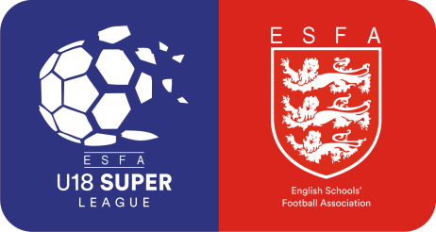

**DATE STRUCTURE**

**Group Phase (Matches will be played on or before the published date below)**

* Match Day 1 Saturday 24th September 2022
* Match Day 2 Saturday 8th October 2022
* Match Day 3 Saturday 5th November 2022
* Match Day 4 Saturday 19th November 2022
* Match Day 5 Saturday 3rd December 2022

**Knockout Phase (Matches will be played on or before the published date below)**

* Preliminary Knockout Round Saturday 14th January 2023
* Round of 32 Saturday 28th January 2023
* Round of 16 Saturday 25th February 2023
* Round of 8 Saturday 11th March 2023
* Semi-Finals Saturday 25th March 2023
* Final TBC

**ACCESSING AND ARRANGING YOUR FIXTURES**

To locate your fixtures, please click [here](http://esfau18superleague.leaguerepublic.com/).

Once you have located your fixtures, please contact your opponents at your earliest opportunity to make arrangements to play fixtures on or **before** the published deadline dates. Both Home and Away team managers have equal responsibility for initiating contact to arrange fixtures. We strongly recommend that date offers are made via email so that you have some evidence available should a dispute arise further down the line.

Deadline dates for completing each round are published online and in this document. The deadline dates must be strictly adhered to as failure to comply with them may result in the fixture being declared void or the points awarded to one team as appropriate. Any requests for an extension to a deadline date must be made via email to [jack.evans@schoolsfa.com](mailto:jack.evans@schoolsfa.com) detailing the reasons why the match cannot go ahead on time or if you have any issues regarding your fixtures. Permission to play during the week following a published deadline date will only be considered if both teams are mutually agreed to go beyond the deadline date The ESFA reserves the right to determine the outcome of the fixture if no result or communication has been received by the deadline date. The only acceptable reason for the match not to go ahead on time is due to inclement weather. This is to ensure that the competition can move forward in a timely manner.



**REPORTING FIXTURE DATES & RESULTS**

Please report the date, venue and kick-off details in advance of your fixtures being played and submit results promptly after each match. This can be done by emailing [jack.evans@schoolsfa.com](mailto:jack.evans@schoolsfa.com).

**RULE SUMMARY**

A more detailed version of the rules is attached with this document, but for your convenience, here are some important matters to note:

|  |  |
| --- | --- |
| **Format:** | 11 v 11 |
| **Ball:** | Size 5 |
| **Duration (League Phase):** | 2 x 45 minute periods. No extra time or penalties. |
| **Duration (Knockout Phase):** | 2 x 45 minute periods. If scores are level after 90 minutes then 2 x 10 periods of extra time will be played. If scores are level after extra time, then the winners of the match will be determined by taking penalty kicks. |
| **Substitutes:** | 5 named players are permitted to be named as substitute. Repeated subs are allowed. |
| **Facilities:** | All matches are played on grass or 3G and 4G pitches where the ‘home’ team gives sufficient notice to the ‘visiting’ team and the venue holds a valid test certificate and appears on The FA’s national FTP register - <https://footballfoundation.org.uk/3g-pitch-register/>. Teams are not permitted to play fixtures on sand based astroturf pitches. |
| **Finance:** | The ESFA is unable to provide any financial assistance towards travel or accommodation in any round of Inter-School national competitions this season. |

Full rules for the tournament can also be downloaded [here](https://schoolsfootball.org/national-competitions/esfa-u18-super-leagues/).

**PLAYER AGE AND ELIGIBILITY CRITERIA**

Only students on the roll of your establishment which have been registered with ESFA HQ on the appropriate form will be eligible to participate in any match in this competition.  Students must be over 15 and under 18 years of age at midnight between 31st August and 1st September in the current playing season will be allowed to play in this competition (Students in Years 11, 12 & 13 only) (please note, girls are permitted to play in mixed football matches up to an including the Under 18 age group in accord with FA rules).



**REFEREES**

**Group Phase:** The home team is required to appoint a neutral and qualified referee and pay the appropriate match fees. If Assistant Referees are not available then each team will be expected to provide one person to act as Assistant Referee throughout the duration of the match.

**Knockout Phase – Preliminary Knockout Round, Round of 32 and Round of 16:** The home team is required to appoint a neutral and qualified referee and pay the appropriate match fees. If Assistant Referees are not available then each team will be expected to provide one person to act as Assistant Referee throughout the duration of the match.

**Knockout Phase – Quarter-Final, Semi-Final and Final:** The ESFA will appoint a neutral and qualified team of officials to all fixtures at the Quarter-Final stage and beyond, provided that at least 7 days’ notice of the match has been received by ESFA HQ. Match fees will be paid by the home team.

Your local Referees’ Association Secretary or County Schools’ FA / FA Referees’ Development Officer may be available to assist with the appointment of Match Officials. Your school is responsible for ensuring that you do not appoint anybody who is suspended or unqualified to officiate. If you are unable to appoint a neutral and qualified referee, then you must inform your opponents before they travel as a matter of courtesy. Team sheets are available to download from the ESFA website. The forms should be completed and submitted to the match referee at least fifteen minutes before kick-off for every match.

**It is important to note that all match officials, if they are not part of your school staff, must hold a current and valid FA DBS / Criminal Record Check to officiate in a fixture at your school.**

**TEMPORARY DISMISSALS FOR PLAYERS (SIN BINS)**

From the start of Season 2019-2020, Temporary Dismissals for Players (Sin Bins) were introduced to improve the match experience for everyone involved with the game in both youth and Schools’ Football. To understand more about the process you can undertake a quick course by visiting <https://www.fareferees.co.uk/temporary-dismissals/> - this course looks at why the scheme was introduced and how referees will apply it on the field of play for players and team officials. You can also access the online seminar which was delivered by The FA Head of Judicial Services, Mark Ives. This has been recorded for your convenience and can be viewed [here](https://schoolsfootball.org/playing-by-the-rules/discipline-in-schools-football/).



**SOCIAL MEDIA AND RESOURCES**

All participating teams will be sent digital assets which you can use on communications and your school / college social media platforms.

To keep up to date with competitions, information and to share your season with us, you can follow @SchoolsFootball on [Twitter](https://twitter.com/schoolsfootball) and [Instagram](https://www.instagram.com/schoolsfootball/). If you are posting social media content regarding this tournament then please remember to tag in @schoolsfootball and use #U18SuperLeague.

**GOOD LUCK!**

Finally, we would like to take this opportunity to wish you and your students the very best of luck for the forthcoming season.

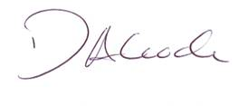

**Darren Alcock**

**Darren Alcock  
Director of Operations**  
English Schools’ Football Association  
email: competitions@schoolsfa.com