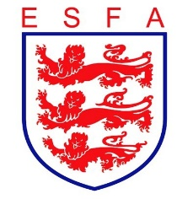
TRUSTEES REPORT
OCTOBER 2021

Mike Coyne, Chair, welcomed Trustees to the meeting and accepted apologies offered

In considering the Association’s financial position, Trustees:
- Received feedback from the professional auditors on the annual financial statements, which all agreed should be signed
- Agreed the “going concern” statement
- Approved one sponsorship contract and received an update on other deals under negotiation
- Received the headline forecast for 21/22, which, subject to some agreed adjustments, remained in line with budget

In considering the Association’s policies, Trustees:
- Agreed changes to the financial regulations to update the expenses policy

In considering the Association’s staffing, Trustees:
- Noted the recent appointments of the Football Projects Manager, the National Competitions Secretary and the Social Media Officer

In considering the Association’s sponsorship and partnership arrangements, Trustees:
- Received a detailed update on the activity delivered under each of the Association’s sponsorships, with pleasing progress in all cases

In considering the Association’s progress against its business plan, Trustees:
- Received an update on the IT portal and the implementation of the approved contingency plans
- Received an update on the progress of the ESFA’s national competitions
- Approved proposals for disbursing resumption of football funding
- Approved the updated PR, marketing and comms strategy
- Received the positive feedback from players from the national finals

In considering the Association’s governance arrangements, Trustees:
- Received their report from the Board Safeguarding Champion
- Received an update on Council vacancies
- Reviewed their proposed rule change for presentation to Council and the AGM
- Approved the Annual Report for presentation at the AGM

Finally, Trustees reviewed all decisions taken during the meeting from a safeguarding and equality and diversity perspective to double-check that appropriate consideration had been given in each case. Trustees conducted their routine review of risks facing the Association and checked that opportunities to engage players in decision making had been considered.

