England U15 Schoolgirls vs ISFA Girls- Match Report

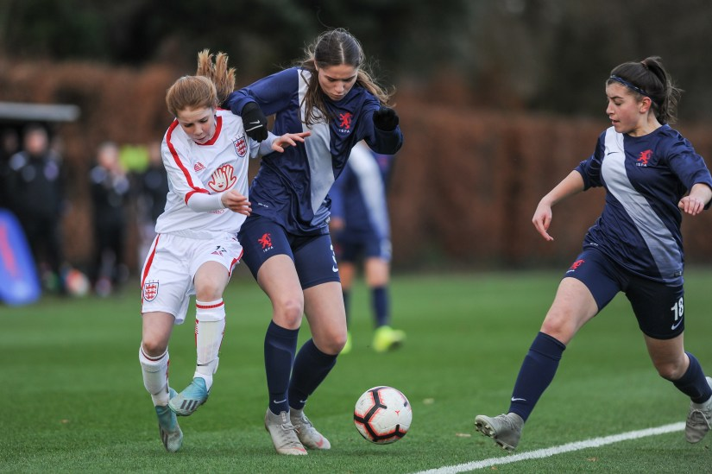
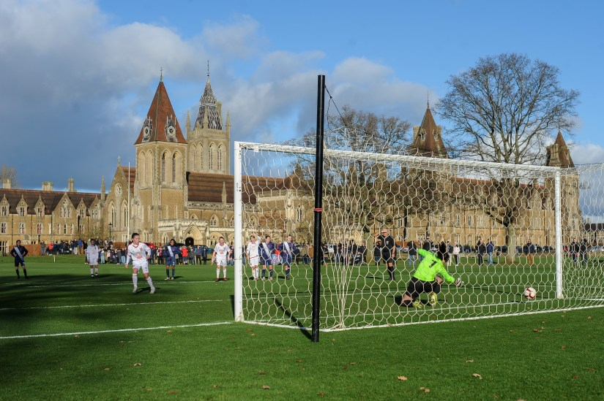
The England Schoolgirls got their international programme off to a positive start with a 2-2 draw against their Independent Schools’ FA counterparts.

After receiving their kits for the upcoming campaign, the squad took to the immaculate surface at Charterhouse School for their first match together since the final squad selection was made in December.

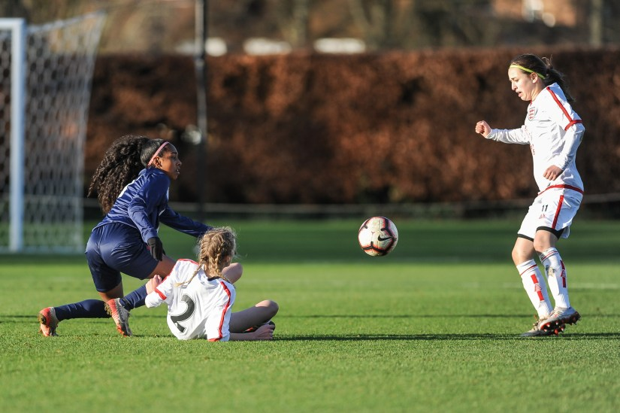
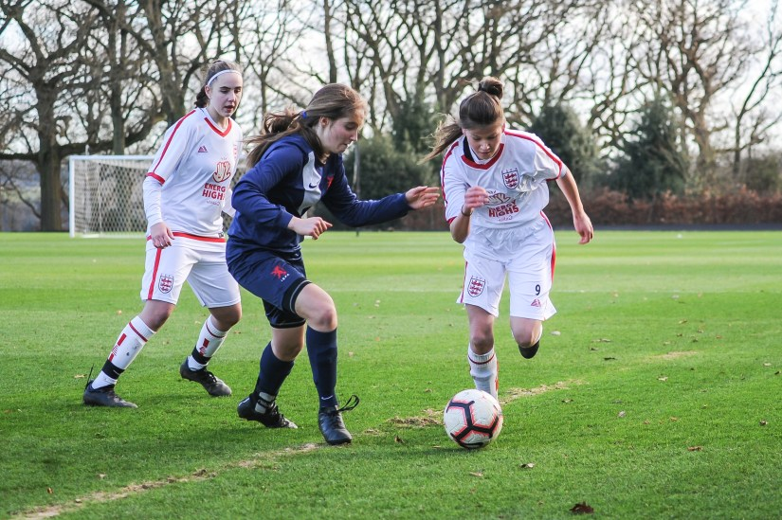
Rebecca Ferguson took the captain’s armband as the England girls settled into their stride early on, creating pressure down both flanks with Leoni Telford and Delphi Cole looking dangerous down the right hand side and Lucy Cooper testing the full back down the left hand side.
Although clear chances were few early on, it was Cole who saw her strike from just inside the box gathered by the home keeper, but shortly after, Megan Sofield stepped up to convert a penalty awarded after a foul just inside the area.
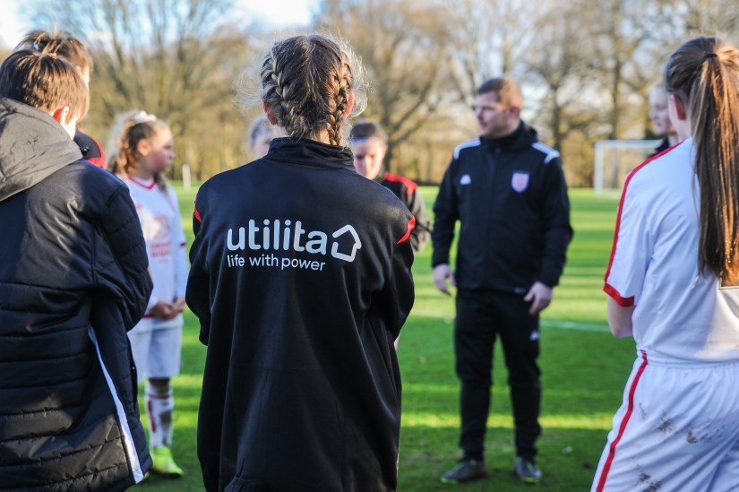
ISFA drew level shortly before the interval but early in the 2nd half Poppy Pritchard was quickest to a through ball in the box and slotted home into the empty net, leaving the defender and keeper stranded.
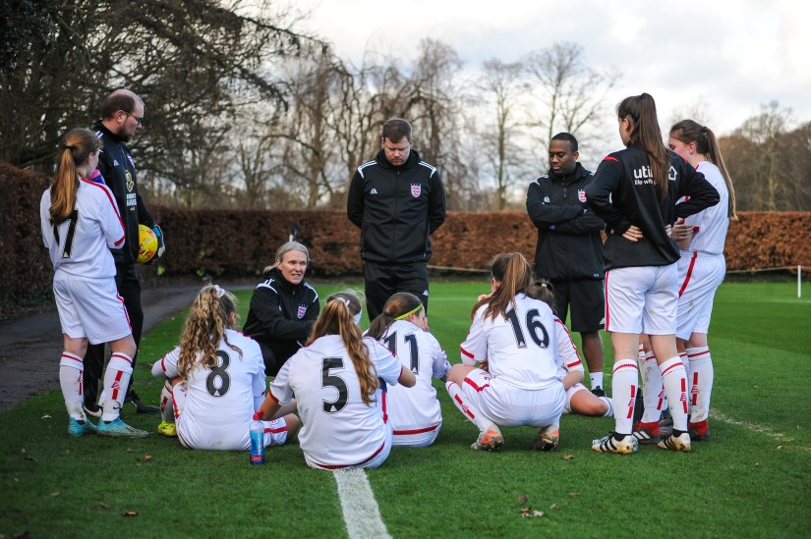

The home side drew level later in the half and that was the end of the scoring for the afternoon in what was a very competitive outing for both teams.
The girls will now prepare for their trip to Eindhoven for their half term training camp, a key part of the preparation for April’s Bob Docherty Cup tournament in Wales.
Thanks to ISFA and Charterhouse School for hosting the fixture and to all parents for their support on the day.
Thank you to 353 Photography for capturing the game, more images available over on their website

