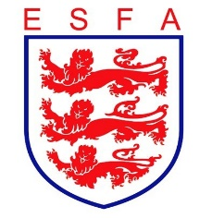
TRUSTEES REPORT
May 2021

Mike Coyne, Chair, welcomed Trustees to the meeting and accepted the declarations of interest made.

In considering the Association’s financial position, Trustees:

- Received a progress report from the Commercial Director
- Noted that one sponsor would not renew their contract for the coming season
- Were updated on the latest Job Retention Scheme claim
- Received and approved proposals from the Rep Committee for securing the required cost savings
- Reviewed income due from the Champions’ Cup competition entries, and adjusted the financial plan accordingly

In considering the Association’s staffing, Trustees:

- Welcomed the appointment of the Governance Manager
- Welcomed the appointment of the PR, Marketing and Comms Assistant

In considering the Association’s sponsorship and partnership arrangements, Trustees:

- Received an update on ongoing negotiations with The FA
- Heard of confirmation of continuation sponsorship from the ESFA’s HE partner

In considering the Association’s progress against its business plan, Trustees:

- Agreed the proposal to seek player views about their experience of rep football this season
- Heard a progress report on the outstanding matters arising from Association restructures
- Noted the take up of “resumption of football” funding
- Received a progress report on the 19/20 and the 20/21 national competitions finals

In considering the Association’s governance arrangements, Trustees:

- Received the routine safeguarding report and an update on the expectations of the Safeguarding Operating Standard
- Gave further consideration to the operation of the Annual General Meeting
- Noted that Council vacancies had been advertised, but with no nominations thus far.

Finally, Trustees reviewed all decisions taken during the meeting from a safeguarding and equality and diversity perspective to double-check that appropriate consideration had been given in each case. Trustees conducted their routine review of risks facing the Association.

