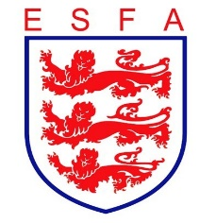
TRUSTEES REPORT
June 2021

Mike Coyne, Chair, welcomed Trustees to the continuation of the extended May meeting of Trustees.

In considering the Association’s financial position, Trustees:

- Received a progress report from the Commercial Director
- Accepted one proposal for a new sponsorship deal
- Accepted one proposal for a new Player Passport partner
- Sought renegotiation of a further potential sponsorship deal

In considering the Association’s policy, Trustees:
- Reviewed The FA’s Safeguarding Operating Standard and received an update on progress towards submission
- Approved proposed changes to insurance guidance

In considering the Association’s staffing, Trustees:

- Approved a hybrid working pilot for staff, once work from home restrictions were lifted
- Agreed the successor role for the departing Football Development Officer

In considering the Association’s progress against its business plan, Trustees:

- Approved the draft submission of the Association’s 3 year strategy to the FA
- Approved the draft KPI definitions for submission to the FA
- Approved the draft business plan in principle, subject to amendments and additions

Finally, Trustees reviewed all decisions taken during the meeting from a safeguarding and equality and diversity perspective to double-check that appropriate consideration had been given in each case. Trustees conducted their routine review of risks facing the Association.

