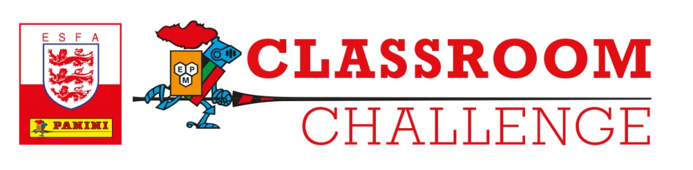
PANINI PREMIER LEAGUE 2021 OFFICIAL STICKER COLLECTION
TERMS AND CONDITIONS
Specific Rules for “Classroom Challenge” Competition January 2021

- The "Classroom Challenge” competition (“Competition”) is open to primary and middle schools in England and their pupils (“Schools”). No employees, agents, contractors or consultants of either the Promoter (as defined below) or of ESFA (English Schools’ Football Association) and their immediate families, the Promoter's associated companies and anyone else professionally connected with the Competition can enter.

- The Competition is open for entries on 11 January 2021 ("Opening Date") and closes on 29 January 2021 ("Closing Date"), unless otherwise specified. The period from the Opening Date to and including the Closing Date shall be referred to as the “Competition Period”.

- The Competition is free to enter and no purchase of any kind is necessary. By entering the Competition, Schools accept and will be bound by these terms and conditions (“Terms”) as well as the General Rules which form part of the Terms and Conditions (click here).

- To enter the Competition, Schools must complete the following steps prior to the Competition Period:
- Register their interest in the competition via the link provided
- Complete registration by 14 December 2020.

- Registered schools will receive their packs and competition worksheets from w/c 11 January 2021

- There is no limit to the number of entries that can be submitted by schools into the competition.

- Each School must adhere to the General Rules (click here) and in particular, to sections 6 and 7. In addition, entries must not contain any:
- pornography, nudity, or sexually explicit imagery;
- abusive, offensive or hateful imagery or language;
- harassing or defamatory content;
- content that compromises the privacy or safety of yourself or others;
- content that demeans a particular gender, sexual orientation, disability, religion, ethnicity or nationality;
- violent or dangerous behaviour; and/or
- spam, advertising or other commercial activities.

- On submission all entries and all materials created, developed or produced in connection with the entry shall become the property of the Promoter. All intellectual property rights (including future rights) in the entry and otherwise arising in connection with the entry are assigned to the Promoter. All moral rights in relation to the entry to which the School may now or at any future time be entitled under the Copyright, Designs and Patents Act 1988 as amended from time to time and under all similar legislation from time to time in force anywhere in the world are waived. The School agrees to take all such action and sign all such documentation as may be necessary to give effect to this section.

- All entries must be completely original so as not to breach any third-party copyright. The Promoter accepts no liability if Schools ignore these Terms and each School agrees to fully indemnify the Promoter against any claims by any third party arising from any breach of these Terms.

- There will be one ‘National Winner’ announced following judging.

- The Promoter shall notify each Winner of their selection within two (2) weeks of the Closing Date (29 January 2021).

- The winner will win the following Prizes:
  - £2,000 cheque for the winning school
  - £50 Amazon voucher for the winning pupil
  - 1 x football shirt for the winning pupil
  - Panini presentation assembly*
*Only to be undertaken if safe to do so in light of COVID-19 government guidelines and school policies.

- The Promoter will use reasonable endeavours to send the Winner Prize to the Winner within two (2) weeks of selecting the Winner.

- In these Terms, “Prize” shall mean a Winner Prize.

- Prizes must be taken as stated and may not be deferred. The Promoter reserves the right to substitute any Prize with a prize of a similar value.

- The Promoter cannot accept any responsibility whatsoever for any technical failure or malfunction or any problem which may result in any Competition entry or other correspondence being lost or not being properly registered.

- In the event of a dispute, the Promoter’s decision is final and no correspondence or discussion will be entered into.

- The Promoter reserves the right to cancel the Competition or amend these Terms at any stage, if deemed necessary in its opinion or if circumstances arise outside its control.

- If a Prize is found to be ineffective, faulty or damaged upon receipt, the Promoter must be notified in writing within seven (7) days of receipt, otherwise the Prize will be deemed to be accepted as received. This does not affect a Winner’s statutory rights (if any).

- Each Winner agrees to take part in any reasonable publicity required by the Promoter.

- If there is any reason to believe that there has been a breach of these Terms or incorrect, illegible, fraudulent or other invalid or improper information has been provided, the Promoter may in its sole discretion refuse to process an entry or fulfil any Prize awarded. If an Entrant fails to comply with clauses 4, 5, 6, 7, 8 and/or 11, they will be excluded from the Competition and their entry will be declared void.

- The Promoter may, at its sole discretion, publish each Winner’s name on the Promoter’s website(s). Each Winner’s name will be made available on reasonable request to those enclosing a self-addressed envelope marked ‘Classroom Challenge Competition’ to the following address: Panini UK Ltd, Brockbourne House, 77 Mount Ephraim, Tunbridge Wells, Kent TN4 8BS within six (6) weeks of the Closing Date.

- General Rules apply to the Competition. Please click here to view the General Rules.

- The “Promoter” is: Panini UK Ltd, Brockbourne House, 77 Mount Ephraim, Tunbridge Wells, Kent TN4 8BS.

- To the extent permitted by applicable law, these Terms shall be construed and interpreted in accordance with the laws of England and the contract between each School and the Promoter shall be deemed to have been formed and performed in England.

