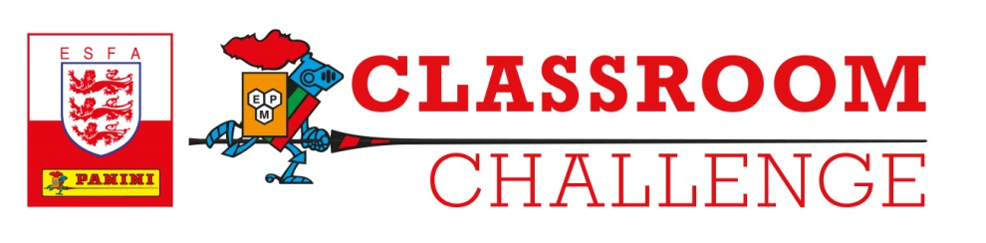
PANINI PREMIER LEAGUE 2021 OFFICIAL STICKER COLLECTION
GENERAL RULES
All promotions operated by Panini in conjunction with the English Schools' FA, and any other promotions where these General Rules have been expressly incorporated, are subject to these rules (the "General Rules") unless otherwise expressly excluded. In the event of conflict between the General Rules and any specific rules published for a particular promotion (the "Specific Rules"), the Specific Rules shall prevail.
The Promoter is: Panini UK Ltd, Brockbourne House, 77 Mount Ephraim, Tunbridge Wells, Kent TN4 8BS, unless otherwise specified in the Specific Rules.
Entrants
1. By participating in any promotion, you are deemed to accept these General Rules and any applicable Specific Rules, together with any terms and conditions of any relevant third party.
2. Promotions are restricted to residents of those countries listed in the Specific Rules. In all cases, employees of the Promoter and its group companies, and their immediate families, their agents or anyone professionally connected to the relevant promotion shall not be entitled to enter.
3. Schools agree to use best endeavours to obtain parental or guardian consent to enable the Promoter to publicise the names of any individual pupils that take part in the competition.

Entry
4. Prize draw promotions are free to enter and unless otherwise stated in the Specific Rules, no purchase of any kind is necessary.
5. You must enter a promotion in the manner and by the closing date and time specified in the Specific Rules. Failure to do so will disqualify your entry.
6. The Promoter does not accept responsibility for any entries which are lost, damaged or delayed as a result of any postal failure, network, computer hardware or software failure of any kind. Proof of sending will not be accepted as proof of receipt. No applications from agents, third parties, organised groups or applications automatically generated by computer will be accepted.
7. For promotions that require you to submit images, videos or other media, the following additional terms apply:
(i) You confirm that your entry is all your own original work and that any materials or information used by you in creating your entry do not and will not infringe the intellectual property, moral or other rights of any third party.
(ii) You confirm that you have not entered into any agreements with third parties that could impair the Promoter's rights to use your entry.
(iii) You must ensure that any person(s) whose image has been used in your entry has given their consent for the use of their image and has waived any rights they may have in the images, videos or other media submitted. If such persons are under the age of 18, you must obtain parental consent.
(iv) If you cannot produce evidence of the consents referred to above, you may be disqualified from the promotion and/or lose any prize.
8. Your entry must not contain any:
(i) pornography, nudity, or sexually explicit imagery,
(ii) abusive, offensive or hateful imagery or language,
(iii) harassing or defamatory content,
(iv) content that compromises the privacy or safety of yourself or others
(v) content that demeans a particular gender, sexual orientation, disability, religion, ethnicity or nationality, violent or dangerous behaviour, and/or
(vi) spam, advertising or other commercial activities, or any other type of content that is indecent, immoral, discriminatory, offensive, or portrays or encourages illegal activities. Any entry that contains such material will be disqualified.
Prizes
9. The decision of the judges is final and no correspondence or discussion will be entered into. The Promoter reserves the right to withhold prizes in the event that it receives an insufficient number of entries or entries of insufficient quality. If you win a prize, you will be contacted on the phone number or email address you provided when entering the promotion. The Promoter will not amend your contact information once you have submitted your entry. Reasonable efforts will be made to contact you.
10. If you win a prize, you will have a fixed time period in which to claim it, as specified by the Promoter. Failure to claim your prize by the time or in the manner specified for the particular promotion will make your claim invalid and Promoter reserves the right to offer the prize to the next eligible entrants selected in accordance with the Specific Rules. Where the prize is time critical and a winner needs to be found before the time to take up the prize, the Specific Rules may state the date on which the winner will be contacted and the Promoter will contact such winner on the phone number (or other method of contact if appropriate) they provided. If the winner cannot be contacted or successful contact is not made on the specified date, the Promoter reserves the right to offer the prize to the next eligible entrants selected in accordance with the Specific Rules. Unless otherwise specified in the Specific Rules, if the prize is not claimed by the winner in the manner and by the specified date set out in the Specific Rules, the Promoter is not obliged to award the prize to the next eligible entrant.
11. Prizes are not transferable, may not be re-sold and are subject to availability. The Promoter reserves the right to substitute any prize with a prize of equal or greater value. No cash alternatives will be offered.
12. Prizes are as described in the Specific Rules and, unless specifically stated to the contrary, will not include tax, insurance, transfers, spending money and other expenses (including meals or personal expenses, upgrades etc.) as the case may be, all of which will be the sole responsibility of the prize winner.
13. The Promoter reserves the right in its reasonable discretion to disqualify you if your conduct is contrary to the spirit of the General Rules, any Specific Rules or the intention of the promotion.
Ownership and use of entries
14. On submission, your entry and all materials created, developed or produced by you in connection with your entry shall become the property of the Promoter. You hereby assign to the Promoter all intellectual property rights (including future rights) in your entry and otherwise arising in connection with your entry. You also waive all moral rights in relation to your entry to which you may now or at any future time be entitled under the Copyright, Designs and Patents Act 1988 as amended from time to time and under all similar legislation from time to time in force anywhere in the world. You agree to take all such action and sign all such documentation as may be necessary to give effect to this section.
15. The Promoter does not guarantee to use or otherwise make available your entry.
Data Protection and Publicity
16. If you win a prize, you agree to take part in any reasonable publicity required by the Promoter.
17. Personal information which you provide when you enter will be held and used only by the Promoter, its group companies, and its suppliers and contractors to administer the promotion and otherwise in accordance with the Promoter's Privacy Policy, the Specific Rules and as expressly agreed by you.
18. All conditions, warranties and representations expressed or implied by law or otherwise in relation to the prize and/or the promotion are excluded to the fullest extent permitted by law.
19. The Promoter shall not be liable for any loss, damage or injury which you suffer as a direct or indirect result of the prize and/or the promotion. However, the Promoter makes no attempt to exclude or limit its liability for death or personal injury caused as a result of its negligence.
General
20. The Promoter reserves the right to alter, cancel or extend a promotion in the event of unforeseen circumstances.
21. The Promoter reserves the right to update and/or amend these General Rules from time to time. Any updates or amendments will not apply to those promotions already underway when the changes are made.
22. These General Rules and any Specific Rules shall be governed by English law and the courts of England and Wales shall have exclusive jurisdiction.

