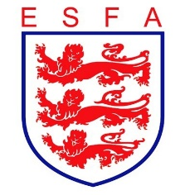
TRUSTEES REPORT
JULY 2020 UPDATE

Mike Coyne, Chair, welcomed Trustees to the meeting, along with the Commercial Director who was in attendance to give his

In considering the Association’s financial position, Trustees:

- Received an update from the Commercial Director and noted the opportunities being pursued;
- Gave further consideration to the implications of cuts in funding from The Football Association, and approved the timed action plan for accommodating these cuts;
- Noted that the first Job Retention Scheme payment had been received from the government;
- Received the cash flow forecast, noting that the payment of significant outstanding invoices had now been made.

In considering the Association’s staffing, Trustees:

- Approved the return to work and part time furlough arrangements for staff, as proposed.

In considering the Association’s progress against its business plan, Trustees:

- Reviewed the progress of the Association’s restructure programme, and determined an extended completion date as a result the delays arising from Covid-19;
- Reviewed report on the three main PR campaigns currently under development and were particularly pleased to see the imminent launch of the “15 benefits of schools’ football” campaign.

In considering the Association’s sponsorship and partnership arrangements, Trustees:

- Heard of a positive first planning meeting with the newly agreed US scholarship partner;
- Received confirmation of the extension of the existing kit supply deal.

In considering the Association’s governance arrangements, Trustees

- Received confirmation of the appointment/re-appointment of Council members, subject to usual appointment clearances.

Finally, Trustees reviewed all decisions taken during the meeting from a safeguarding and equality and diversity perspective to double-check that appropriate consideration had been given in each case. The routine review of the Risk Register concluded, with changes approved as proposed.

