ESFA England Schoolboys U18 0 – 1 Northern Ireland Schoolboys U18

Centenary Shield / Match Three

Friday 5th April 2019
Match Attendance – 1079
Full Match - https://www.youtube.com/watch?v=4_laR0-AEp8
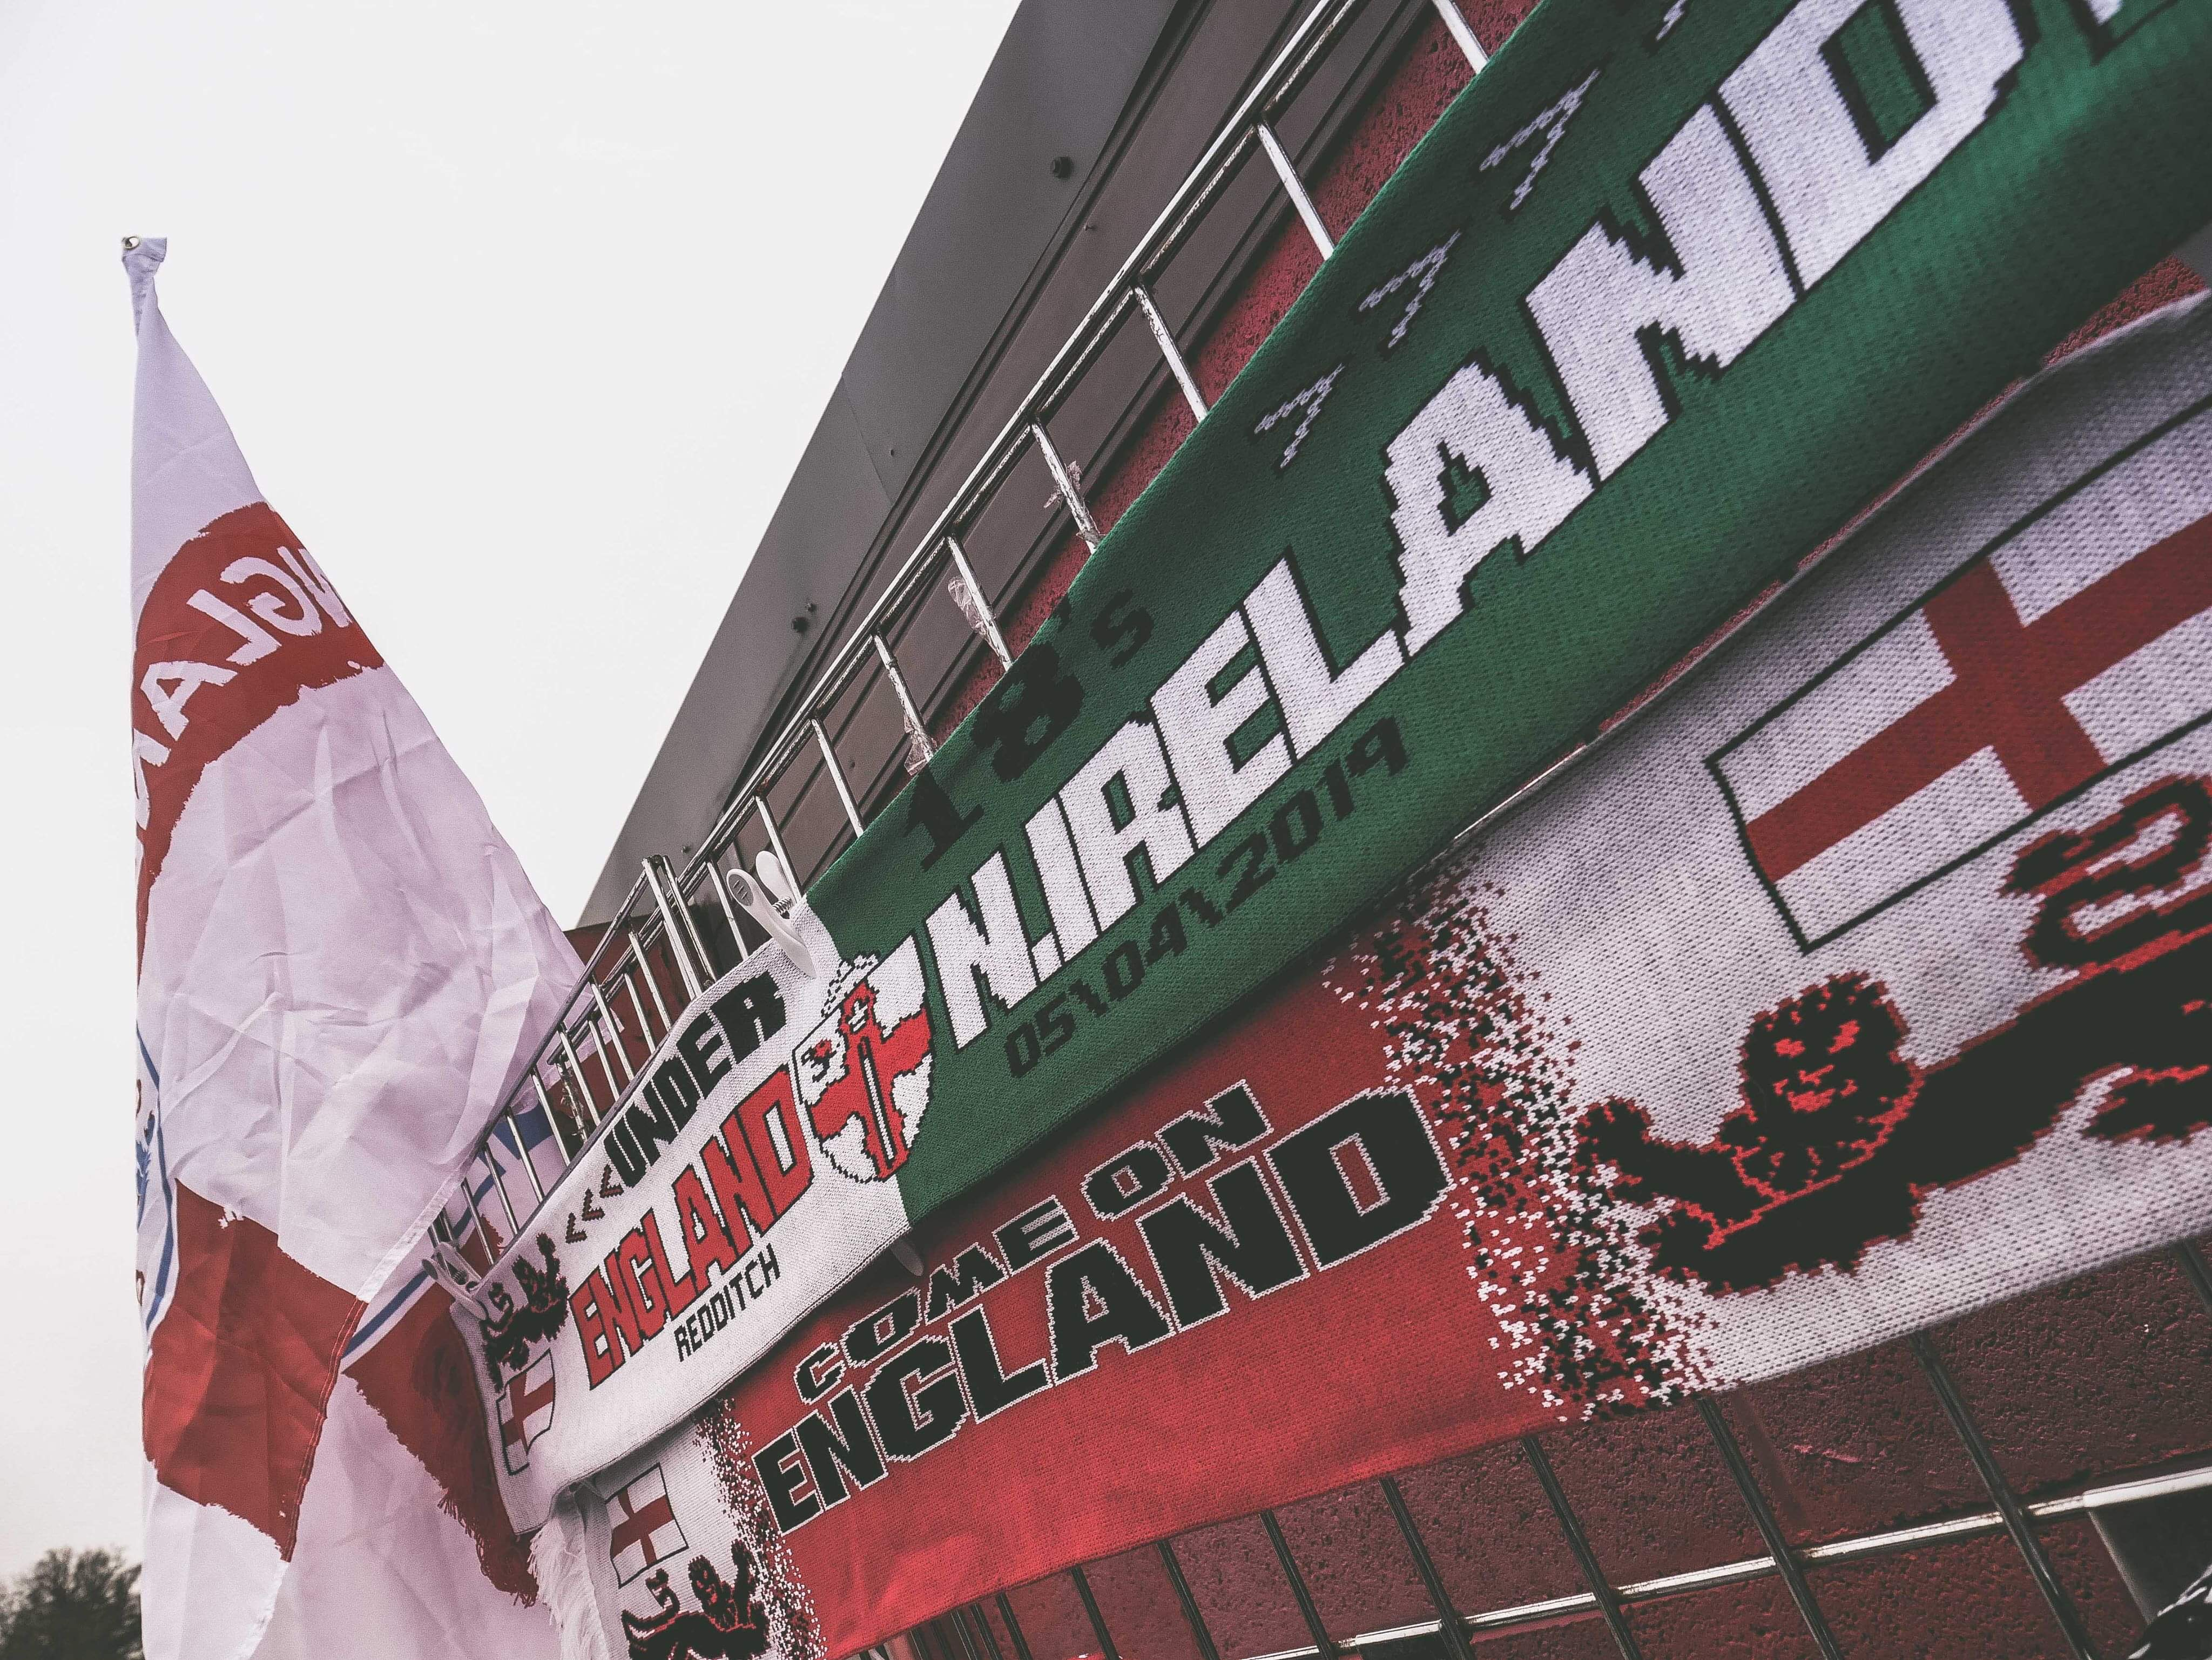A highly competitive Centenary Shield fixture at Redditch United’s The Trico Stadium results in a share of the spoils for both England and Northern Ireland.

On April 5th 2019, fresh from a 0 – 2 victory the England Schoolboys took to the field for their third fixture of the Centenary Shield against a Northern Ireland team sat at the top of the table.

Position | Team | MP | W | D | L | Pts | GF | GA | GD
1st | Northern Ireland | 2 | 2 | 0 | 0 | 6 | 2 | 0 | 2
2nd | England | 2 | 1 | 0 | 1 | 3 | 2 | 1 | 1
3rd | Wales | 2 | 1 | 0 | 1 | 3 | 1 | 1 | 0
4th | Republic of Ireland | 1 | 0 | 1 |  | 1 | 1 | 1 | 0
5th | Scotland | 2 | 0 | 1 | 1 | 1 | 1 | 4 | -3
The Northern Ireland schoolboys came out of the blocks fast, not allowing England any time on the ball to play and were looking dangerous from set pieces. On England’s first forge forward, Dickson picked up the ball up and drove through the heart of the midfield. After a quick one-two with Rule, he might have been a tad unlucky not be awarded a penalty after a Collision in the box (5th minute).
The first clear cut chance fell to Northern Ireland after a long ball over the top found the Irish number 9, but he was well closed down by Tickle who forced the early shot and made the save. The remainder of second half saw both defences coming out on top for England. Cartwright expertly marshalled the midfield and back four of Storey, Tarbotton, Taylor and Crowther stopped everything that came their way and made it difficult for the Irish to get in behind.
The half-time interval came and although England were under some early pressure they weathered the storm and got themselves into the game, with the scores level at 0 - 0 the second half was poised nicely for whichever team could find the cutting edge and push on.
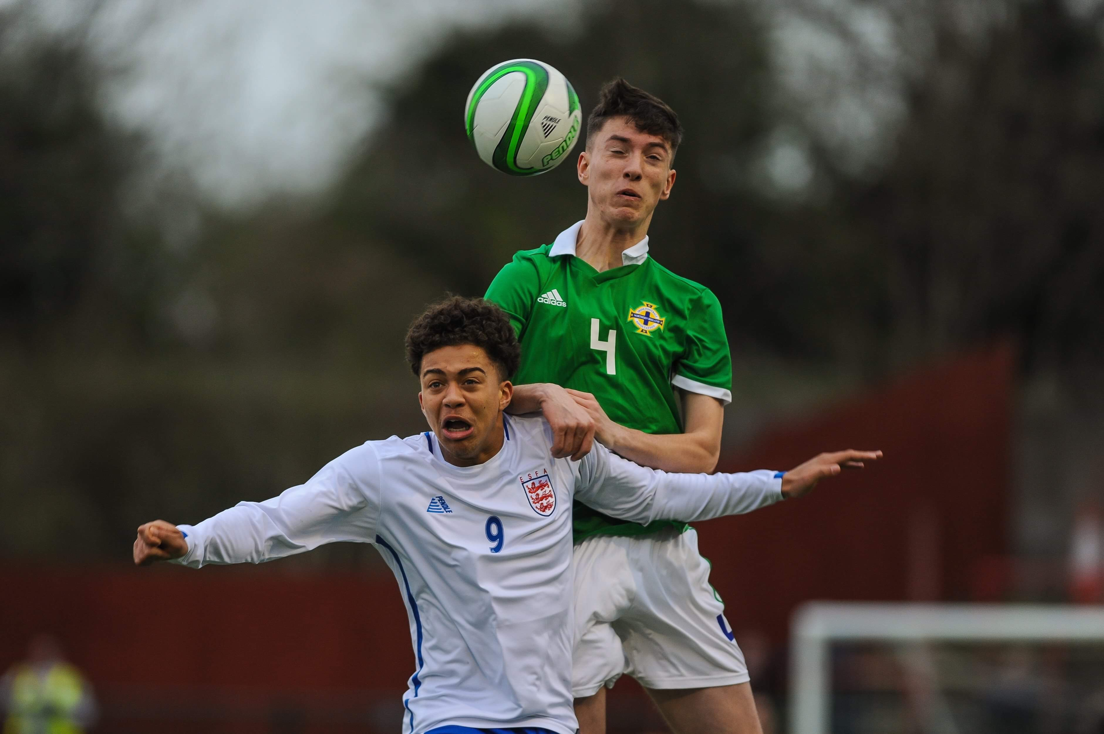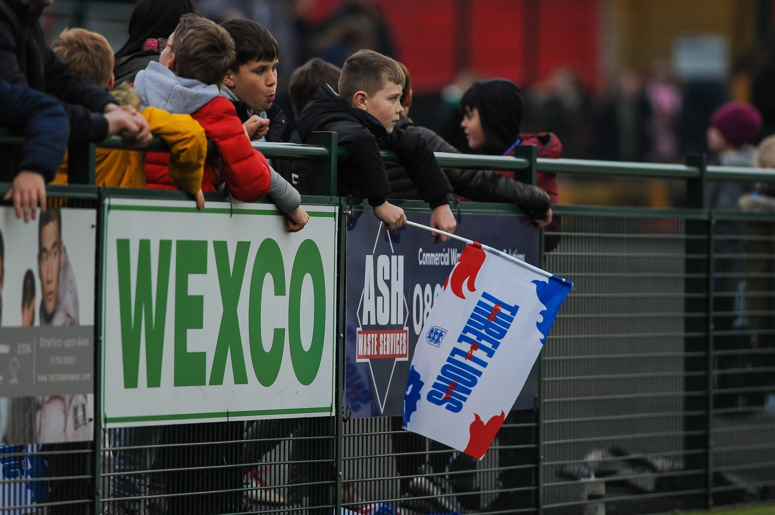Half-Time – ESFA England Schoolboys U18 0 – 0 Northern Ireland Schoolboys U18

After the break, it was England that came out the better, asking questions of the Irish defence with crosses into the box and probing possession. On the 64th minute, Rule worked some space and unleashed a shot from the edge of the box, but it sailed just wide. As the game edged closer to full-time, England were throwing caution into the wind in the hope of finding the opening goal.

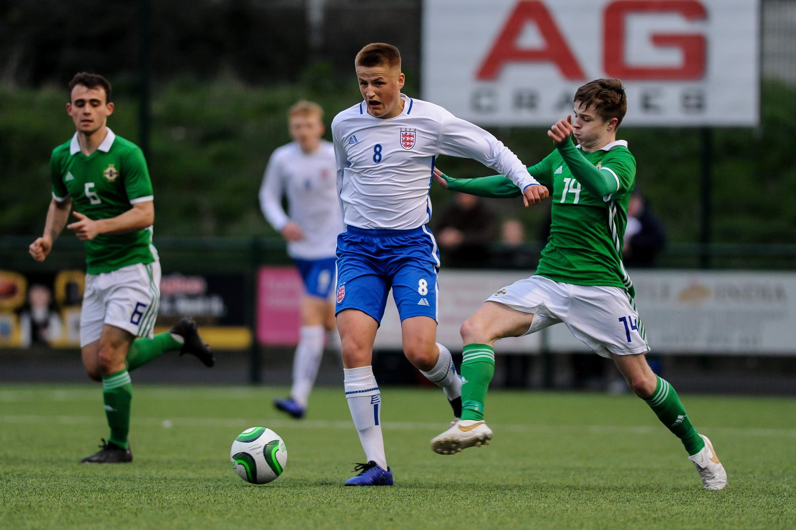

After a corner in the 83th minute, they thought they found it - the ball was whipped in by the first half substitute Crowther. His physicality had already been causing the Irish problems and it was at this point that he climbed the highest and thundered a header into the net however, a foul in box was called ruling no goal for England.
England threw everyone forward in the closing minutes but it just wasn’t meant to be. The full-time whistle rang and the game finished honours even which was probably a fair reflection of the game.
Position | Team | MP | W | D | L | Pts | GF | GA | GD
1st | Northern Ireland | 3 | 2 | 1 | 0 | 7 | 2 | 0 | 2
2nd | England | 3 | 1 | 1 | 1 | 4 | 2 | 1 | 1
3rd | Wales | 2 | 1 | 0 | 1 | 3 | 1 | 1 | 0
4th | Republic of Ireland | 1 | 0 | 1 |  | 1 | 1 | 1 | 0
5th | Scotland | 2 | 0 | 1 | 1 | 1 | 1 | 4 | -3
England’s next Centenary Shield outing sees them at Dalymount Park, Dublin to face the Republic of Ireland Schoolboys on April 12th 2019, Kick-off at 7pm. Best of luck England and bring home the three points!

