

   
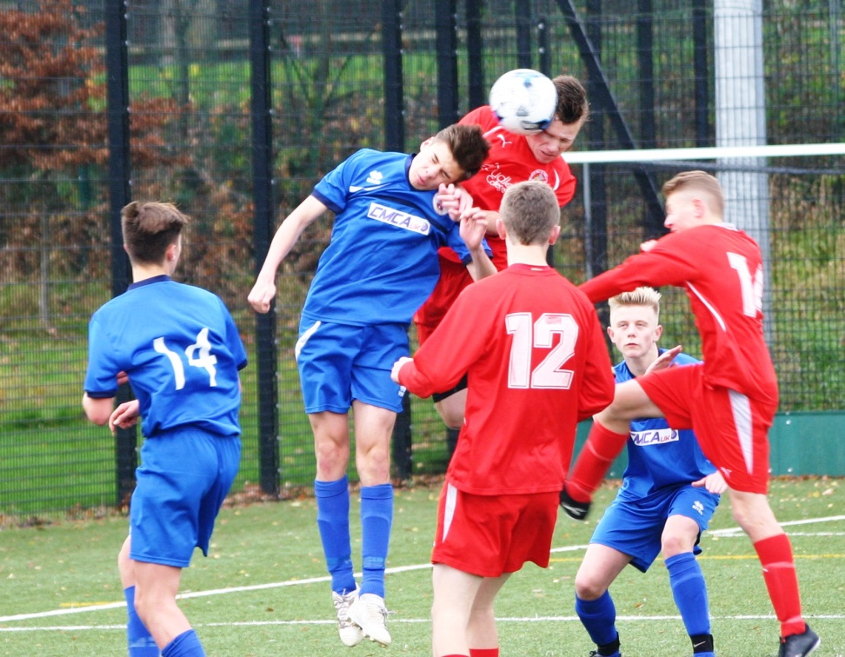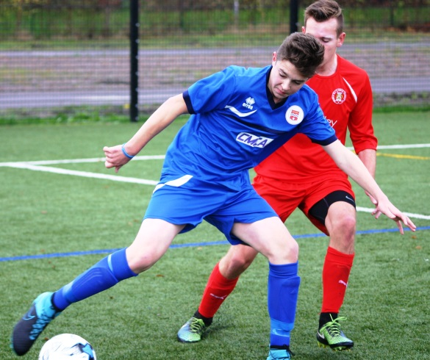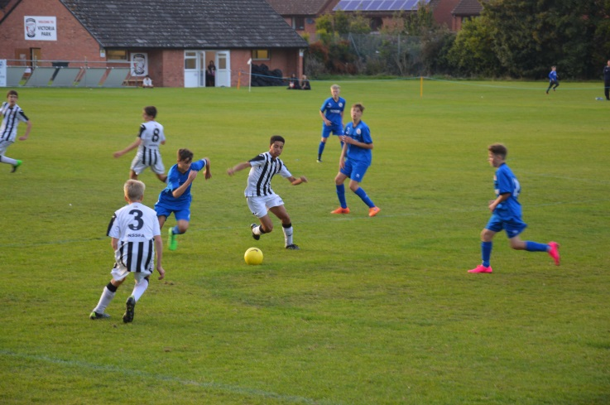

**Herefordshire Shools FA**

**Commercial Partnership Opportunities**

*“Everything I have achieved in Football is due to playing Football with my friends.”* – Zinedine Zidane.

**The Herefordshire Schools Football Association**

**proud and dedicated**

Herefordshire Schools FA is one of the smallest Schools Football Associations in the Country. But what is lacked in size, is more than made up for in stature.

Since it was reconstituted in May 2013, Herefordshire Schools FA is now far more commercially aware and recognises the need for marketing and strategic planning to secure the long term future of the game in our county. Herefordshire Schools FA is a volunteer run organisation and supports football in Schools in Herefordshire, providing competitions and education. We therefore guarantee: *any year end surplus is ploughed back into the game through development activities,* such as safeguarding children, facility investment, medical investment and youth football to name but a few.

We operate 6 KS3 and KS4 County Cup competitions, and County representative teams, who compete in regional and national competitions. Also with over 30 primary teams potentially competing every week in Herefordshire Schools Tournaments and over all secondary schools competing in County and National competition, there is no doubt that The Herefordshire Schools FA provides the opportunity for perspective partners to access and contact the heart of the local community.

We offer advertising in our packages with various competitions and leagues and also on our new dynamic website, **HerefordshireSchoolsFA.com,** and we have the opportunity to post on the Herefordshire FA’s Facebook and Twitter accounts thanks to the support of the Herefordshire FA. The website continuing to grow as we integrate online advertisement, alongside social media. The Twitter **@HerefordshireFA** has grown to over 5,500 followers and over 800 likes on Facebook, meaning your business will gain heavy exposure online through one of our commercial partnerships.

We can offer advertising in our Cups with the opportunity to have a marketing presence at the venue of the Finals to promote their business, products and services and distribution of flyers. Herefordshire Schools FA is committed to ensuring that all partners receive maximum exposure and recognition of being a supporter of schools football.

The Herefordshire Schools Football Association can offer flexible payment options making it easier for you to get involved in the Nations favourite sport.

Please feel free to contact Herefordshire Schools FA’s Football Coordinator, Dan Chance, on 01432 342179 or at [Dan.Chance@HerefordshireFA.com](mailto:Dan.Chance@HerefordshireFA.com) if you would like to speak to him about any of the sponsorship or partnership opportunities available.

**Herefordshire Schools Football, the facts….**

* Over 30 schools playing in Primary Tournaments
* Over all schools playing in Secondary Tournaments
* Links to National Governing Body
* Links to Herefordshire FA
* Providing more playing opportunities year on year
* Twitter Followers – 5,500
* Website hits over 7,000 visits per month.
* Facebook Likes – 800

Would you like to be linked with International brands such as The FA and Nike?



* **Press launch with photos and press releases sent to regional and specialist media.**
* **Box on Front Page and on the leagues page.**
* **Exposure through The Herefordshire FA’s Twitter and Facebook social media (one post monthly)**
* **Monthly News Item on HSFA Website**
* **2 x Guest passes to each Final for the sponsor.**
* **Prominent 1 x a5 page in the Cup Final programme.**
* **Company Logo on all official Herefordshire SFA communications**

**Please contact Dan Chance by email on Dan.Chance**[**@HerefordshireFA.com**](mailto:Roger.Goodwin@HerefordshireFA.com) **for full details about this package.**

(NB: Packages can be altered and negotiated to suit your business needs)

**Herefordshire Football Association Headline Sponsor**

**PRICE: POA**

The Herefordshire Schools FA is an established brand linked to the English Schools Football Association. With over 30 primary schools and every secondary school in Herefordshire affiliated.

**What can we offer you?**

**Representative Team Sponsor (2016/2017)**

**PRICE: POA**

* **Official Match-Day/Match ball sponsor or 2 year partnership opportunity.**
* **Passes for sponsor plus guest to home games.**
* **Press launch with photos and press releases sent to regional and specialist media.**
* **Exposure on http://www.herefordshireschoolsfa.co.uk**
* **Exposure through The Herefordshire Twitter and Facebook social media.**
* **Website link to your website.**
* **Opportunity to be included in a minimum of one mail-out during the season.**
* **An a5 advert in all Representative match-day programmes**

**Please contact Dan Chance by email on Dan.Chance**[**@HerefordshireFA.com**](mailto:Roger.Goodwin@HerefordshireFA.com) **for full details about this package.**

(NB: Packages can be altered and negotiated to suit your business needs)

The Herefordshire Schools FA runs representative sides up to under 16s level and gain large exposure around the various counties. The players are selected from local schools to represent their county on a wider stage. This includes travelling around and playing fixtures against various other County teams, and experiencing a more professional outlook in order to develop the players’ abilities and potentially move them on to the next level.

The county teams wear fully branded matching uniforms on match day and during travel. The opportunity is present for your business to be advertised via our junior players’ in various areas of the country.

**Medal Sponsors**

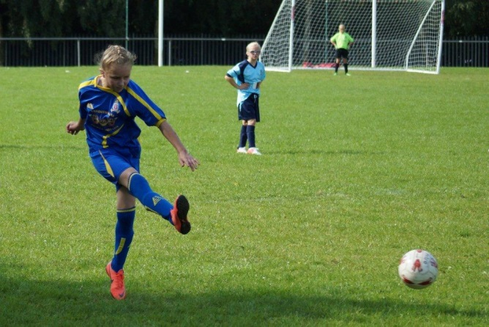

**Ribbons**

The HSFA

Sponsorsing a ribbon on the individual medals allow your company to be seen by players, parents and spectators as a lasting momento.

**POA**

* **Press launch with photos and press releases sent to regional and specialist media.**
* **Recognition as the Title Sponsor of the HSFA e.g. HSFA Sponsored by……**
* **Box on HSFA page**
* **Exposure through The Herefordshire FA Twitter and Facebook social media (one post monthly)**
* **Monthly e-shot to membership database featuring over 2,000 people.**
* **1 x a5 page in the Cup Final programme.**
* **Company e-flyer sent to HFA Marketing Database featuring over 2,000 contacts.**
* **Full exposure on HerefordshireFA.com - averaging 5000 visitors a month.**
* **Website link to your website.**

**Please contact Roger Goodwin** [**Roger.Goodwin@HerefordshireFA.com**](mailto:Roger.Goodwin@HerefordshireFA.com) **for full details about this package.**

(NB: Packages can be altered and negotiated to suit your business needs)

Herefordshire Schools FA stages a number of representative matches and 6 County Cup Finals each season, for which souvenir programmes are produced. Matchday programmes are a great value way of advertising your business as they frequently are seen by hundreds of people.



**Advert Size Representative Match County Cup Finals**

*(Black & White) (Full Colour)*

**Quarter Page** £40 £75

**Half Page** £75 £135

**Full Page** £125 £200

**PRICES SHOWN ARE PER MATCH, DISCOUNT AVAILABLE FOR SEASON BOOKINGS**

**a picture TELLS a thousand words**

**Matchday Programme Advertising**

**THE SHOWPIECE OF SCHOOLS FOOTBALL**

**HSFA Cup and Competition Sponsorship (2016/2017)**

The Herefordshire Schools County Cup Finals are the showpiece competition, competed for by all the High Schools in Herefordshire and with the highest profile Final’s, played each year at Hereford FC’s Edgar Street Stadium.

* **Press launch with photos and press releases sent to regional and specialist media.**
* **Recognition as the Title Sponsor of the competition e.g. Herefordshire U14’s Cup Sponsored by……**
* **Full exposure on HerefordshireFA.com - averaging 7000 visitors a month.**
* **Exposure through The Herefordshire FA Twitter and Facebook social media (one post monthly)**
* **Exposure through The Herefordshire Twitter and Facebook social media.**
* **Monthly e-shot to membership database featuring over 2,000 people.**
* **Opportunity to Present Cup at final**
* **2 x Guest passes for each Final for the sponsor plus guest.**
* **1 x a5 page in the Cup Final programme.**
* **Company e-flyer sent to HFA Marketing Database featuring over 2,000 contacts.**

**Please contact Dan Chance** [**Dan.Chance @HerefordshireFA.com**](mailto:Roger.Goodwin@HerefordshireFA.com) **for full details about this package.**

(NB: Packages can be altered and negotiated to suit your business needs)

**PRICE: POA**

Herefordshire Schools FA can offer a range of advertising options that allow you to promote your business to our ever- expanding database of Football enthusiasts.

**HerefordshireschoolsFA.com**

Updated daily and receiving over 7,000 separate visitors per month and this figure continues to grow as we integrate online advertisement alongside social media. We can offer aesthetically complete to your design, boxed advertising space on our homepage with links to your website.

**Take advantage of modern marketing**

**Media Packages**



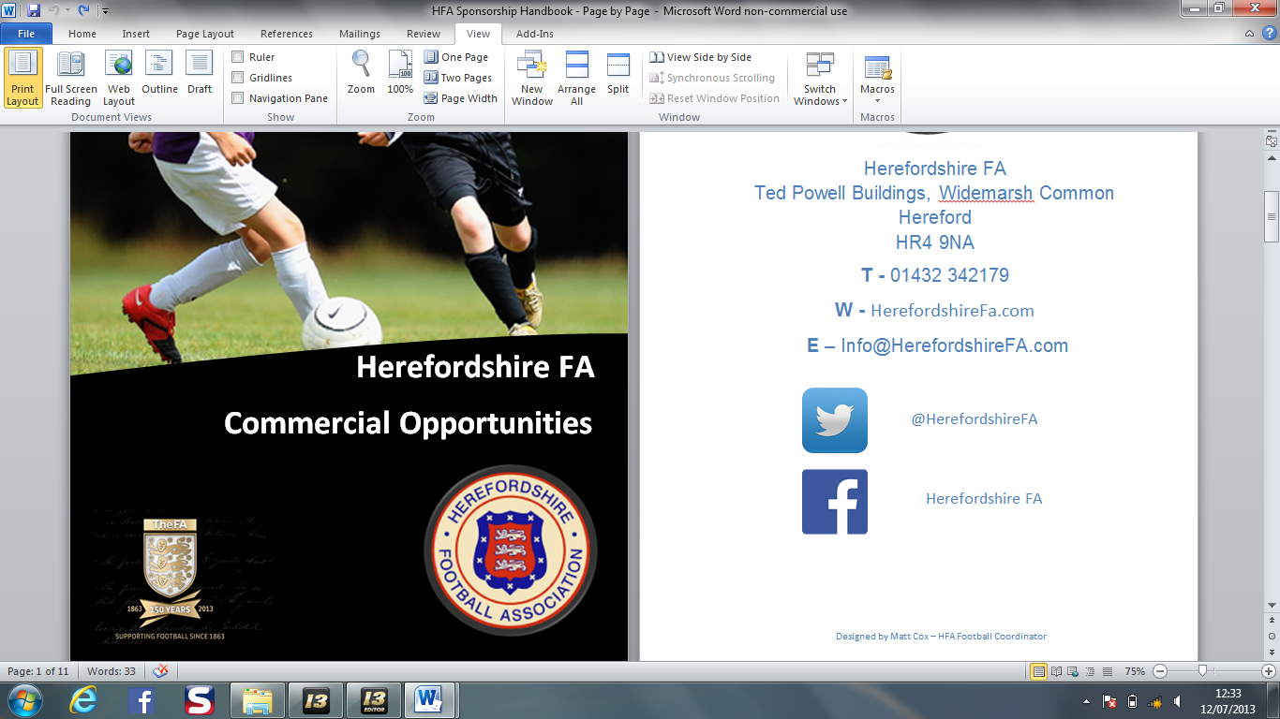

**@HerefordshireFA**

**Herefordshire FA**

Herefordshire Schools FA

Ted Powell Building, Widemarsh Common

Hereford, Herefordshire

HR4 9NA

**T –** 01432 342179

**W –** http://www.HerefordshireschoolsFA.co.uk

**E –** Info@HerefordshireFA.com